Assignment #3: Unit Plan
Names: Bryn Willis and Rileigh Grahame-McMullan
Grade Level: 4
First Peoples’ Principle: Learning is holistic, reflexive, reflective, experiential and relational (focussed on connectedness, on reciprocal relationships, and a sense of place)
Big Idea: Artists experiment in a variety of ways to discover new possibilities.
Curricular Competency: Exploring and Creating
- Create artistic works collaboratively and as an individual using ideas inspired by imagination, inquiry, experimentation, and purposeful play
Content Expectation
- Element of Design: Texture
  - Aspect of that Element: Textures can be real or illusionary, There are many techniques for creating both real and illusionary textures

Discovery
Curricular Competency: Exploring and Creating
Create artistic works collaboratively and as an individual using ideas inspired by imagination, inquiry, experimentation, and purposeful play
Materials:
- Pencil
- Eraser
- Sketchbook (or piece of blank paper)
- Nature object (chosen by the individual students)
- Magnifying glass

Formative Assessment: Non-judgemental critique
- Looking just at the drawing of the initial object, which draws your attention?
  - Where do you notice texture the most in this piece?
  - What techniques do you think the artist used to create texture?
  - Do you think the artist chose an interesting spot on their object to magnify?

Consolidation
Curricular Competency: Reasoning and Reflecting
Connect knowledge and skills from other areas of learning in planning, creating, interpreting, and analyzing works for art

Critical Analysis Process
Artist: M.C. Escher
Name of work: Day and Night
Year it was created: 1938
URL: https://www.aaronartprints.org/escher-dayandnight.php
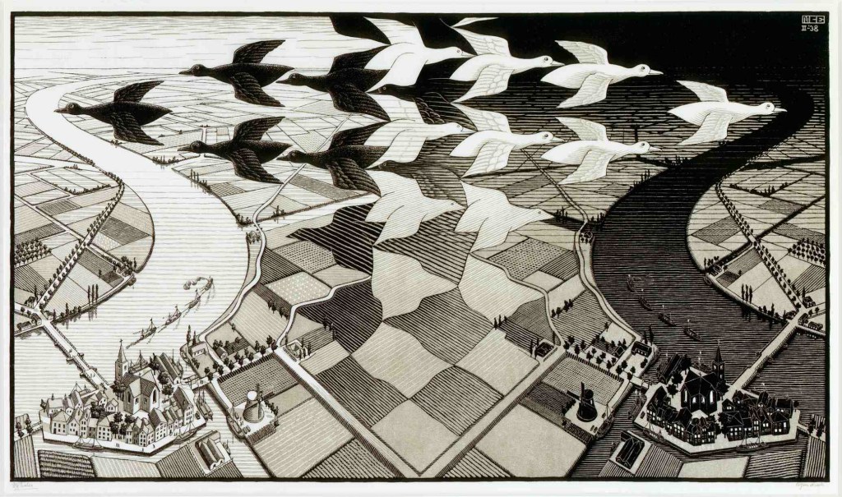
Initial reaction:
- What is the first thing you notice in this piece?
- Where do you notice the texture in this piece?

Description:
- What do you see in this piece?
- Why do you think he chose to do this piece in black and white?

Analysis:
- Where can you see magnification in the piece?
- Did the artist use different techniques to create texture?

Cultural context:
- Created by M.C Escher in 1938
- M.C. Escher was very interested in both math and art
- His art was made with mathematically inspired woodcuts
- The right side of the painting looks like a daytime scene with a long canal running through a brightly lit city whereas the left slide is the exact opposite it is a night scene with the canal and the sky black

Informed point of view:
- What do you think of his work now?
- Can you see the two different sides of the piece now?

Assessment:
Formative assessment: clip-board self-check with teacher follow-up
Prompts:
- What stood out the most to you about the piece?
- Where did you see texture in this piece?
- What do you think about him only using black and white in this piece?

Practice
Curriculum Competency: Exploring and Creating
Choose artistic elements, processes, materials, movements, technologies, tools, techniques and environments using combinations and selections for specific purposes in art-making
Materials:
- Paint (Various colours)
- Paint pallets (1 per student)
- Leaves (approximately 3 per student)
- Paintbrushes (1 per student)
- Magnifying glasses (1 per student + 1 for the teacher)
- Cups with water to clean the brushes between paint colours (1 per student)
- Paper (1 per student)
- Napkins to wipe the paintbrushes with
Activity:
- Set up all of the materials on a table
- Have the students gather a paintbrush, a cup of water, a piece of paper, a paint pallet, some napkins and 2-3 leaves
- Have the students come to the table either 1 at a time or in small groups to receive some paint on their paint pallets
- Once the students have collected all of their materials, provide each of them with a magnifying glass.
- Have the students take one of their leaves and their magnifying glass, and have them look closely at the textures on the leaf. The teacher can follow along with the students and gently guide them.
- Once the students have thoroughly examined their leaves and their textures, tell the students to keep those textures in mind when painting their leaves. The students’ leaf prints should show as many details as possible.
- Now the students can begin to paint. Tell the students to cover their entire leaf with paint, then once it has been covered, they can carefully stamp it onto the paper. The students can use multiple colours on a leaf or only one, but they should have multiple colours on their paper at the end.
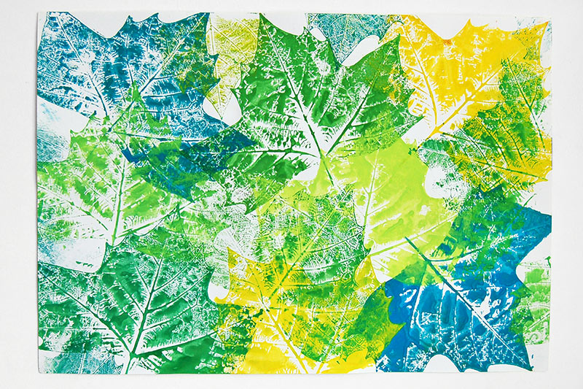
What the students’ leaf print could look like in the end. Retrieved from https://www.firstpalette.com/craft/leaf-prints.html

Assessment: Self-reflection
Prompts:
- What did you notice when using this technique to show texture?
- Where did you see the most texture on your leaf?
- Did the lighter or darker colours imprint the textures better onto the paper?
Explain how your assessment relates to the Content and Curricular Expectations, First Peoples’ Principle:
The self-reflection assessment relates to the Content and Curricular Expectations and First People’s Principle because it lets the students reflect on the technique that they used in this activity to create texture using leaves and paint.

Inquiry:
Curricular Competencies:Exploring and creating
- Create artistic works collaboratively and as an individual using ideas inspired by imagination, inquiry, experimentation, and purposeful play

Inquiry Question: ”Using different mediums, what textures can you create using a sponge?”
Materials:
- Sponges (at least 1 per student)
- Paper (2 per student)
- Paint
- Chalk
- Oil pastels
- Markers
- Plasticine
- Cups with water for rinsing paint off of sponges
Activities:
- Set up all of the materials on a table.
- Provide each student with 1 piece of paper
- Have the students go through the mediums one at a time, seeing how the sponges create textures on the piece of paper.
- Tell the students to think of a tree that holds meaning to them. It could be a tree that is located somewhere special (ex. in their backyard, in a park) or it could even be meaningful because of an event that surrounded the tree (ex. christmas, fruit picking, on a camping trip)
- Once the students have finished experimenting with the mediums, they will now get a new piece of paper to create an image of their meaningful tree using at least one of the mediums that they just experimented with.
- The students must create textures on the tree using the sponge.
- Tell the students to think about whether the tree has leaves or not, and if it does have leaves, what colour the leaves will be based on the season. What else could be on the tree?
- If the students have time left over, they can also add a background that reflects the season they chose for their tree.
Approximate amount of time needed: 30 minutes (10 minutes for experimenting with each medium and 20 for the creation of the tree picture)

Reflection:
Curricular Competency: Reasoning and Reflecting
- Reflect on creative processes and make connections to other experiences.
Method of Reflection: Video compilation of students discussing their tree projects
Steps:
- Have the students use a class set of iPads to get into pairs and film each other while they discuss their tree projects.
- The videos will then all be compiled and can be watched by the whole class and the teacher.
Prompts for students to discuss while they are filming:
- Why is the tree that inspired your project meaningful to you?
- How did you use texture to enhance the meaning?
- What surprised you most when you were experimenting with the sponge and the mediums?
- What is another medium that we didn’t experiment with that you think would make interesting textures when used with a sponge?

Assessment for the Unit:
- Summative assessment that is assessed by the teacher. The teacher will assess the students work by watching the compilation of the students discussing their tree projects as well as by taking into account the responses that were done earlier in the self-reflections and the critical analysis. The students will be graded on their progress in the unit based on the scale pictured below.
